Dalton Murray

Systems Analysis and Design

INT 6123 – Systems Analysis and Design

Dr. Andrew Makar

October 22, 2023

**IA #7 Spring Breaks R Us**

**Develop a simple network diagram that includes all four SBRU subsystems assuming all server side hardware and software resides at the SBRU home office.**

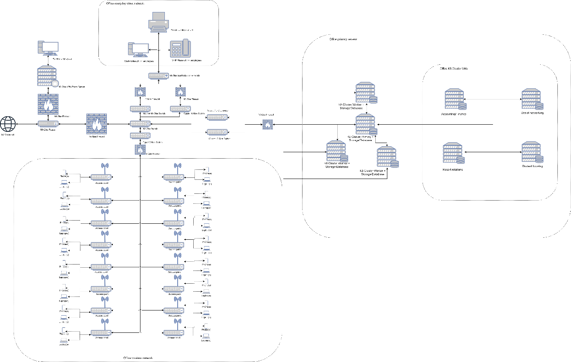

**References**

Satzinger, J. W., Jackson, R. B., & Burd, S. D. (2016). Systems analysis and design in a Changing World (7e ed.). Cengage Learning.

I have neither given nor received unauthorized aid in completing this work, nor have I presented someone else's work as my own.

*Dalton Murray*